CLOUD COMPUTING


SUBMITTED TO
SIR WAQAS SALEEM

SUBMITTED BY
HAMNA MAHMOOD
2023-BSE-025
BSE V-A

Lab 07
Lab Title
Environment Variables, PATH, UFW, and SSH Key Authentication
Task 1 — Print & filter environment variable
- Print all environment variables
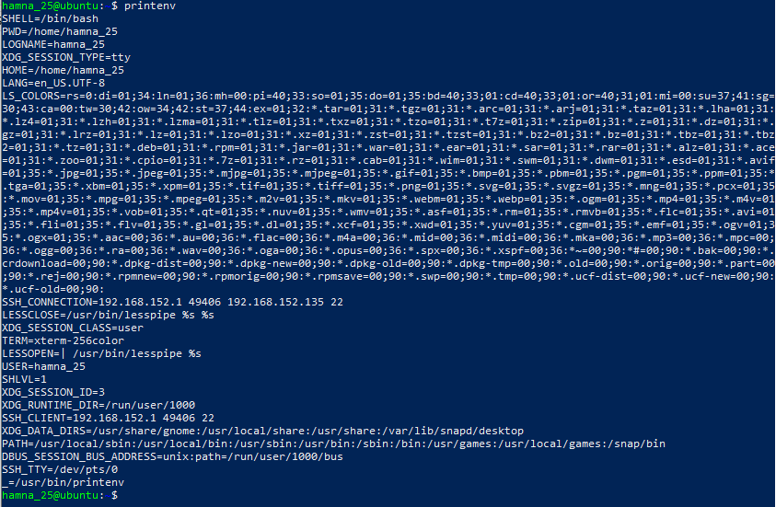
- Filter for SHELL, HOME and USER.
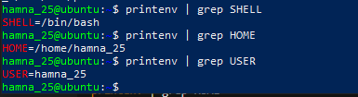
Task 2 — Export DB_* variables temporarily and observe scope
- Define all DB_* variables (run the three exports one after another). Capture them in one screenshot showing the three export commands and their execution.
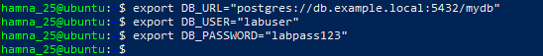
- Echo the three variables (run the three echo commands together) and capture one screenshot showing their outputs.
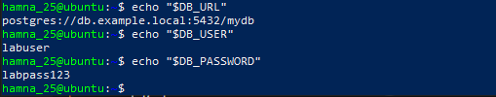

- Show all DB_ variables with a single grep command (capture that output).
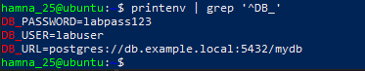

- Close the bash session (exit) and reopen a new terminal. Verify variables are gone using echo and grep together.
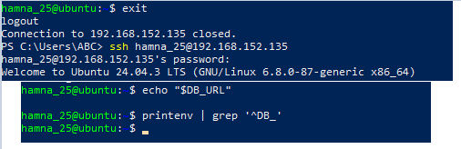

Task 3 — Make DB_ variables persistent in ~/.bashrc*
Open ~/.bashrc in an editor and append the three export lines. Capture the editor showing the three lines added (single screenshot).
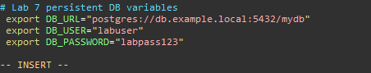
Source ~/.bashrc and then immediately run the three echoes and the grep filter. Capture all commands together in one screenshot.
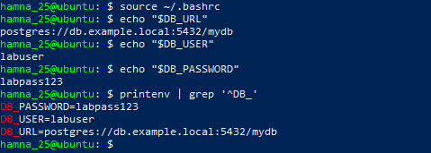
Close and reopen terminal. Run echo and grep together to confirm persistence. Capture both in one screenshot.
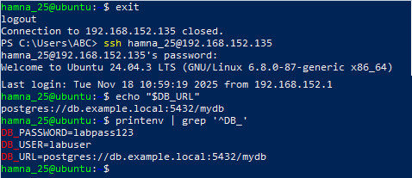
Task 4 — System-wide environment variable, welcome script, and PATH
View /etc/environment before editing and save the screenshot.
Show the current PATH value.
Edit /etc/environment and add the Class variable. Capture the editor showing the added line.
Show the updated file containing the Class line.
After re-login, show the Class variable and PATH in a single screenshot.
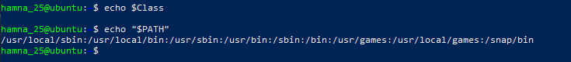
Create a welcome script named welcome in your home directory and make it executable. Capture the creation and chmod together.
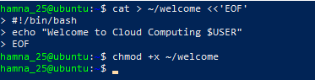
Execute the script with ./welcome and show the output.
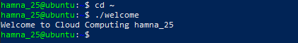
Add your home directory to PATH inside ~/.bashrc. Capture only the editor view showing the PATH line. 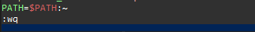
Apply the PATH update and run welcome directly. Capture source + welcome output together.
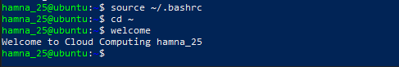

Task 5 – Block and allow SSH using ufw (firewall)
- Enable ufw and show status (group both commands in one screenshot if you run them together).
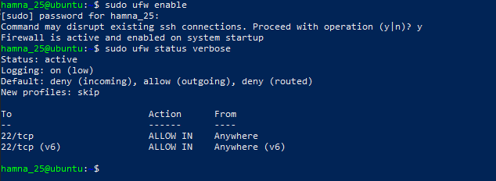
Deny TCP port 22 and show status (run deny and status numbered together and capture in one screenshot). Use short form as requested.
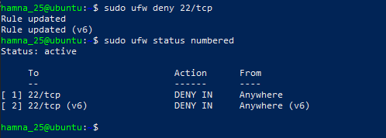
From Windows host attempt to SSH (expected to fail) — capture the host-side SSH attempt in one screenshot:
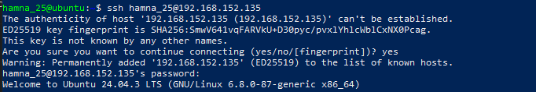
Allow SSH back and reload, then show status (group allow, reload, status in one screenshot if run together). Use short form as requested.
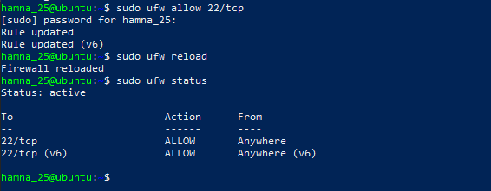
From Windows host attempt SSH again (should succeed) — capture successful login in one screenshot:
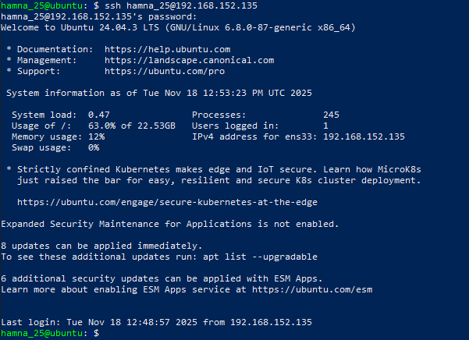
Task 6 — Configure SSH key-based login from Windows host
Generate ed25519 key pair (if needed) and show the generated files in one screenshot (run ssh-keygen and then list ~/.ssh):
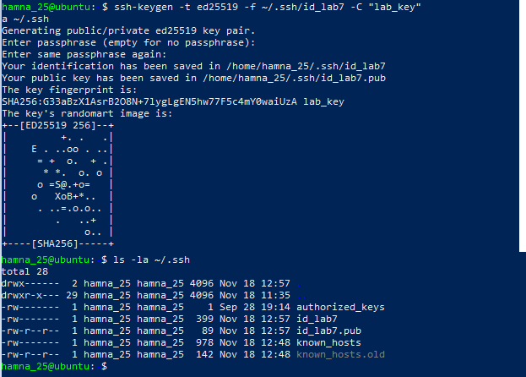

Show the public key content (single screenshot):
Clear the known_hosts file content and verify it is empty (single screenshot):
Connect to Ubuntu Server (Initial Connection)
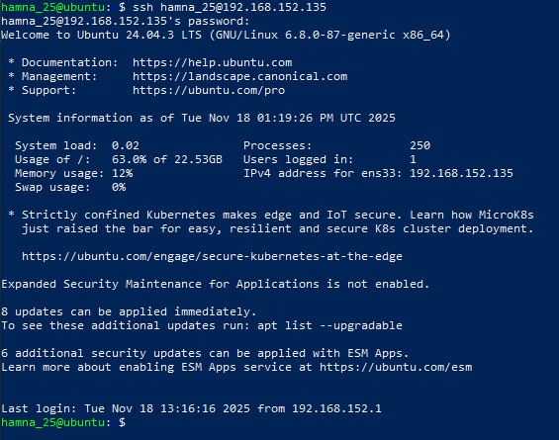
Verify known_hosts Updated
B: Ubuntu Server (Server-Side)
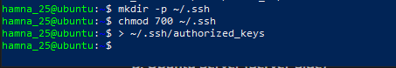

Append Public Key and Set Permissions
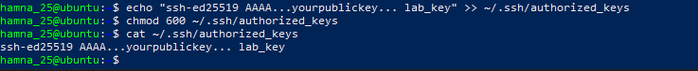
Test Passwordless Login from Windows
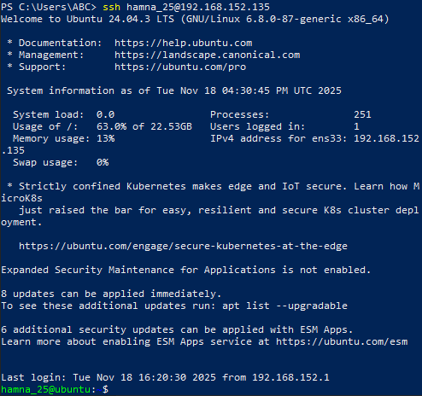
Test Explicit Identity Usage
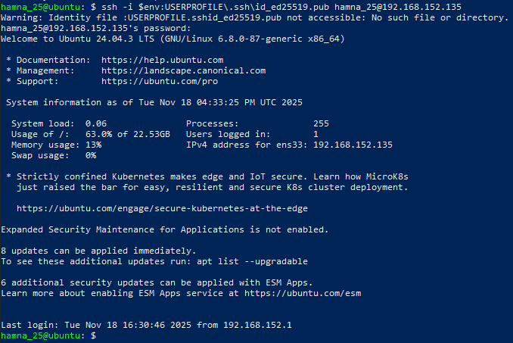
Exam evaluation questions
Q1: Quick Environment Audit
Show all environment variables
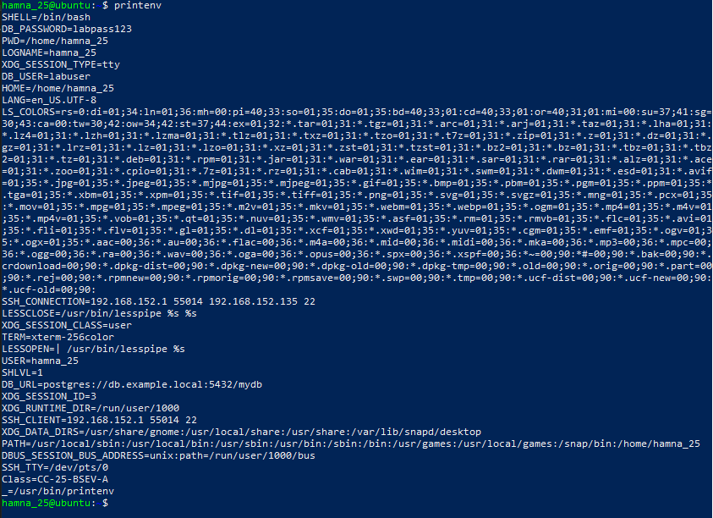
Show PATH, LANG, and PWD (three commands, together on screen)
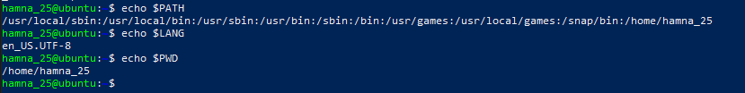
Q2: Short-lived Student Info
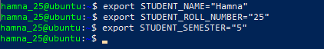
Print them using echo
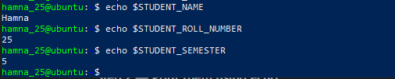
Show all STUDENT_ using grep*
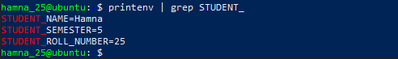
Open NEW terminal → variables should be gone
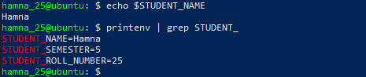
Q3: Make It Sticky (Persistent Environment Variables)
Edit bashrc and add exports at bottom
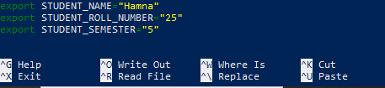
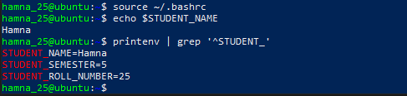
Close terminal → Open NEW terminal
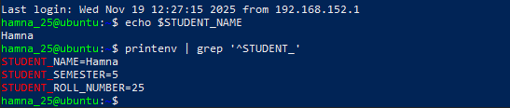
Q4: Firewall (ufw) Rules — Block/Restore ICMP Ping
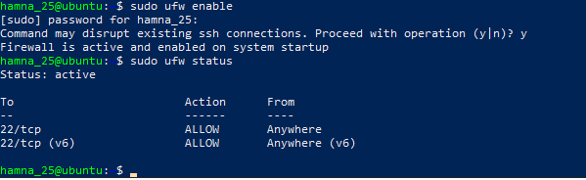
Block ICMP ping
Since ICMP protocol doesn’t work directly on Ubuntu we need to go inside the nano file to edit /etc/ufw/before.rules, which is a file UFW reads before applying rules, and changed the echo-request rule from ACCEPT to DROP to block ping.
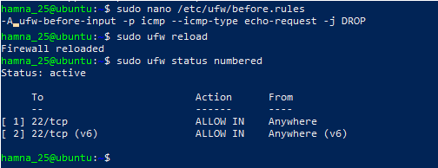
Test ping from Windows (should fail)
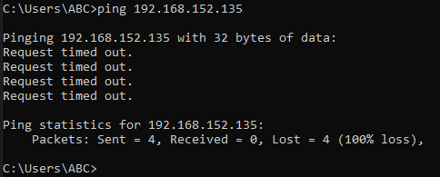
Re-allow ping (undo the change)
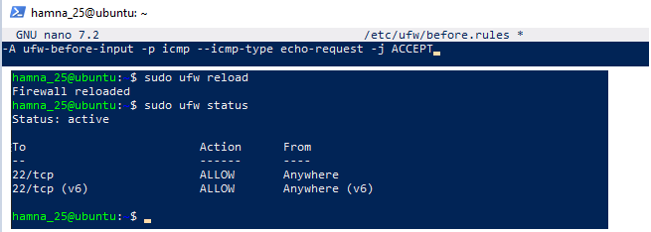
Test ping (should succeed)
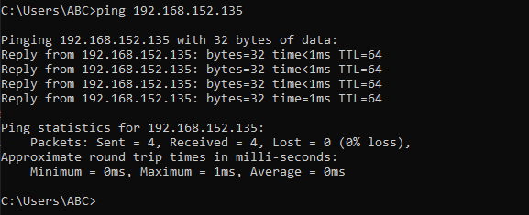
Ping succeeded now because we changed the rule in /etc/ufw/before.rules back from DROP to ACCEPT, allowing ICMP echo-request packets again.
After reloading UFW, the firewall stopped blocking ping, so the server responded normally to ping requests.

